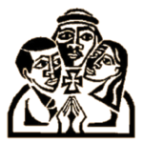
Living Stones of the Holy Land Trust (Registered Charity No 1081204).
2021 Michael Prior Memorial Lecture
‘Christians in the Arab World and Interreligious Dialogue’
Cardinal Michael Fitzgerald
11.30. Saturday November 20

Cardinal Michael Fitzgerald is a leading figure and scholar in interreligious relations. He is an internationally recognised expert on Christian–Muslim relations in the world today with nearly four decades of experience in religious exchange and diplomatic engagement. He has had the rank of archbishop since 2002. At his retirement in 2012, he was the papal nuncio to Egypt and delegate to the Arab League. He headed the Pontifical Council for Interreligious Dialogue from 2002 to 2006. Pope Francis raised him to the rank of cardinal on 5 Oct 2019.

Father Michael Prior (1942-2004)
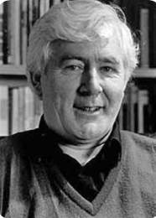
A founder of Living Stones, Michael Prior was a priest of the Vincentian Congregation, Professor of Biblical Theology at Saint Mary’s College (now Saint Mary’s University, Twickenham) and a strong advocate of Palestinian People, their rights and for Justice.

The parish hall at Holy Apostles Church, Pimlico, London SW1V 4NE. The entrance to the hall is at 47 Cumberland Street. Please see ‘How To Find Us’ on the parish website at https://www.holyapostlespimlico.org/ All are welcome to this event, which is free, although a £10 voluntary donation is suggested. Please indicate your intention to attend this event via admin@livingstones.ngo.

